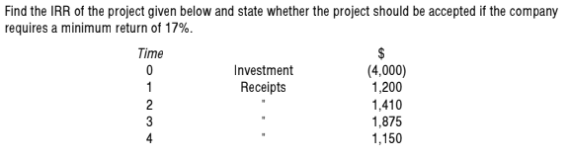

(Marks 10)

Question. 02

A company is considering two mutually exclusive options, option A and option B. The cash flows for each would be as follows.

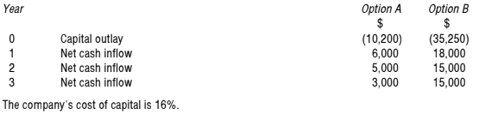

Required:

Evaluate & suggest company that which project should be undertaken. (Marks 10)